Supplementary Materials for: Ahn et al.

(Title)
The Activation of NLRP3 Inflammasome Potentiates the Immunomodulatory Abilities of Mesenchymal Stem Cells in Murine Colitis Model

Ji-Su Ahn^{1,†}, Yoojin Seo^{2,†}, Su-Jeong Oh¹, Ji Won Yang², Ye Young Shin¹, Byung-Chul Lee³,Kyung-Sun Kang³, Eui-Suk Sung⁴, Byung-Joo Lee⁵, Tae-Hoon Shin^{6,*} and Hyung-Sik Kim^{1,2,*}

¹ Department of Life Science in Dentistry, School of Dentistry, Pusan National University, Yangsan 50612, Republic of Korea
² Dental and Life Science Institute, Pusan National University, Yangsan 50612, Republic of Korea
³ Adult Stem Cell Research Center and Research Institute for Veterinary Science, College of Veterinary Medicine, Seoul National University, Seoul 08826, Republic of Korea
⁴ Department of Otorhinolaryngology, Head and Neck Surgery, Pusan National University Yangsan Hospital, Yangsan, Gyeongsangnam-do 50612, Republic of Korea
⁵ Department of Otorhinolaryngology-Head and Neck Surgery, Biomedical Research Institute, Pusan National University School of Medicine, Pusan National University Hospital, Busan 49241, Republic of Korea
⁶ Translational Stem Cell Biology Branch, National Heart, Lung, and Blood Institute, National Institutes of Health, Bethesda, MD 20892, USA
* Correspondence: taehoon.shin@nih.gov ; Tel.: +1-301-827-0565 & hskimcell@pusan.ac.kr ; Tel.: +82-51-510-8231
† These authors contributed equally to this work.
Supplementary Figure 1

Figure S1. The expression of negative and positive marker for MSCs. a, CD14, CD31, CD34 and CD45 expression was analyzed as negative marker for MSCs. b, Expression of positive markers including CD29, CD44, CD73 was analyzed.

A
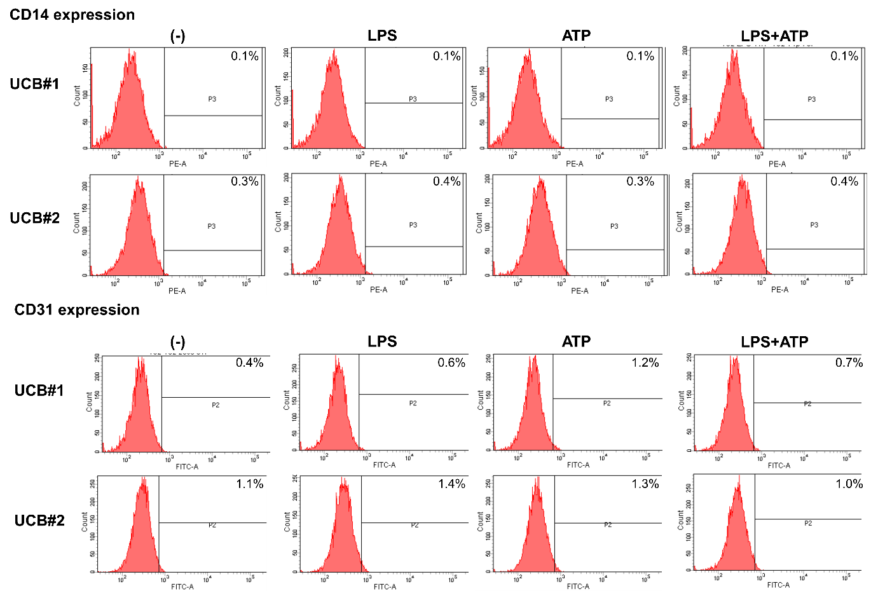
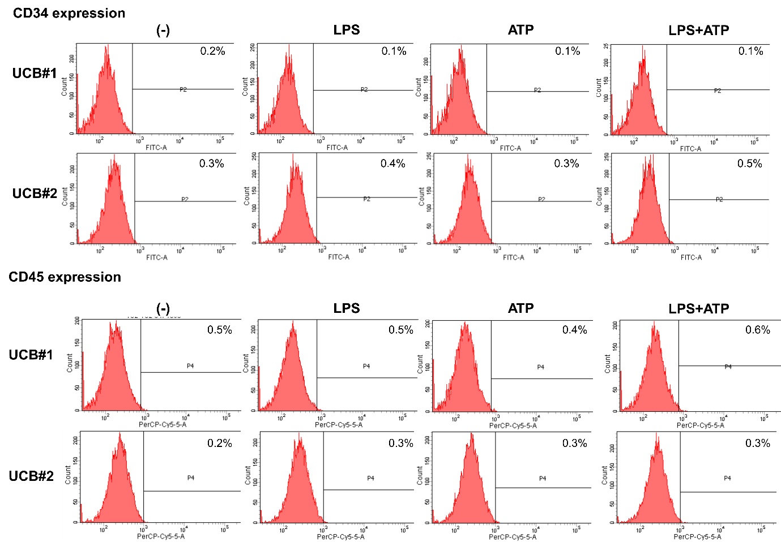

B